**Directions for Writing Answers**

**In a PDF file and emailing back to teachers**

1. Once you save the file, open the file in Adobe Acrobat Reader. This is a free download you can get from Adobe, many computers already have this loaded.
2. Once opened in Adobe off the desktop, click on the button called Fill & Sign:

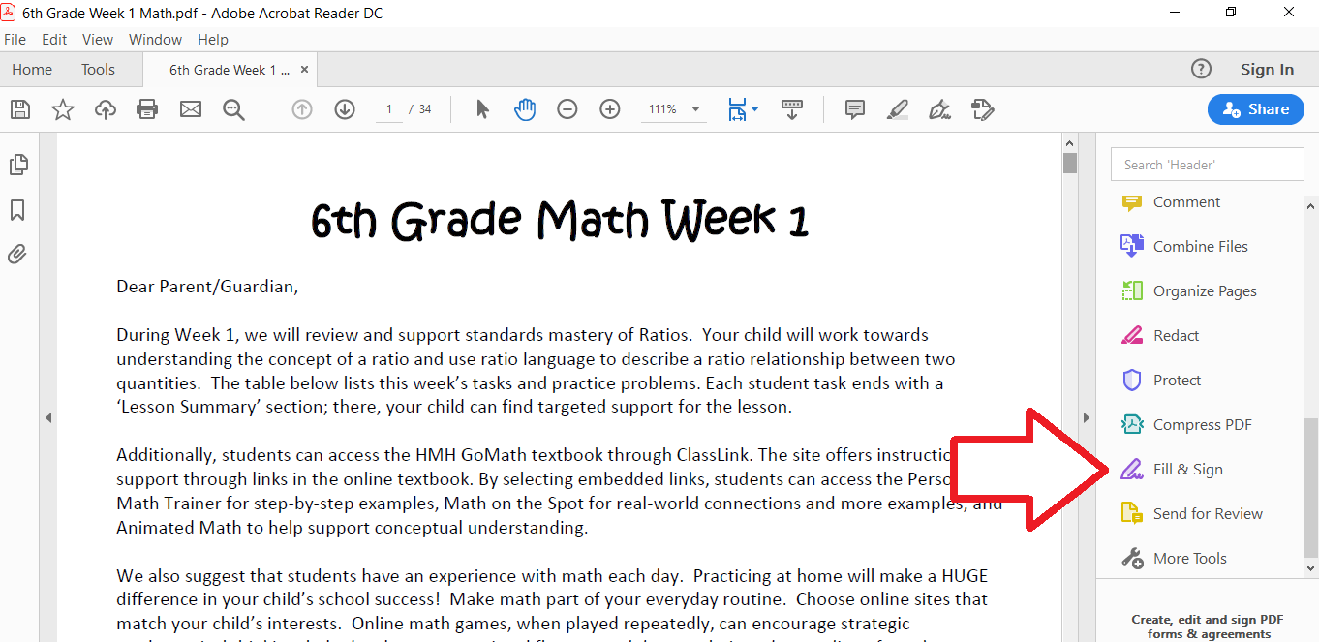

1. Click the You Option, Fill and Sign.
2. Click on Text and move over to Name or any underlined section and click the right mouse button:

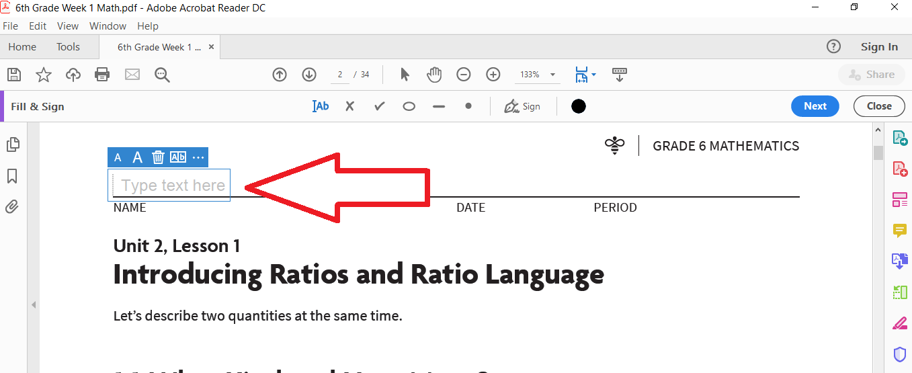

1. Start typing your Name or text to answer the question:
2. Once finished, Go to File tab and click on Save As:
3. **Save your file by adding a dash and last name to the file**
4. To send to teacher, open up your Outlook email and send the file with name attached to the appropriate teacher.